Python Implementation of GPIO:

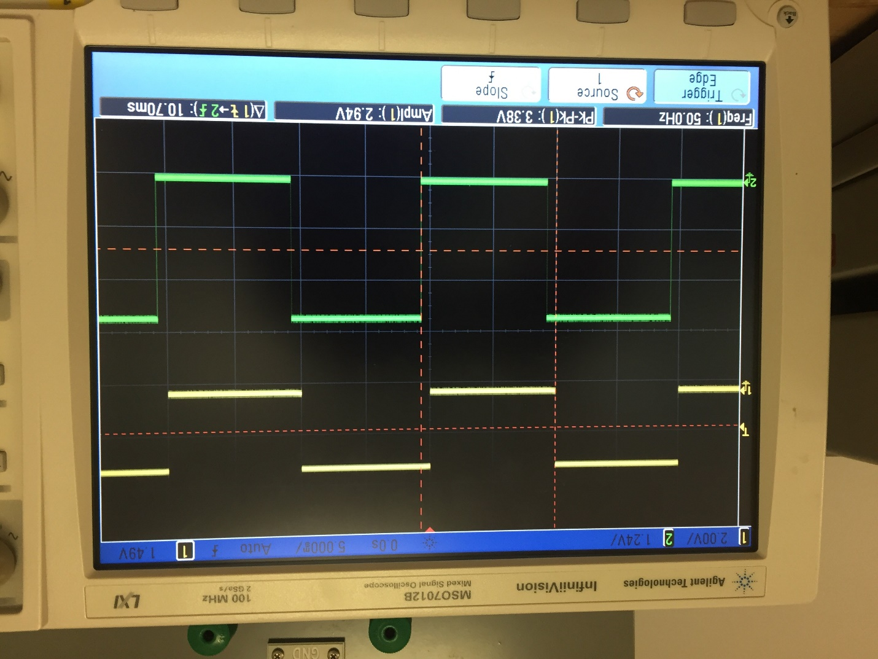

Kernel Driver Implementation: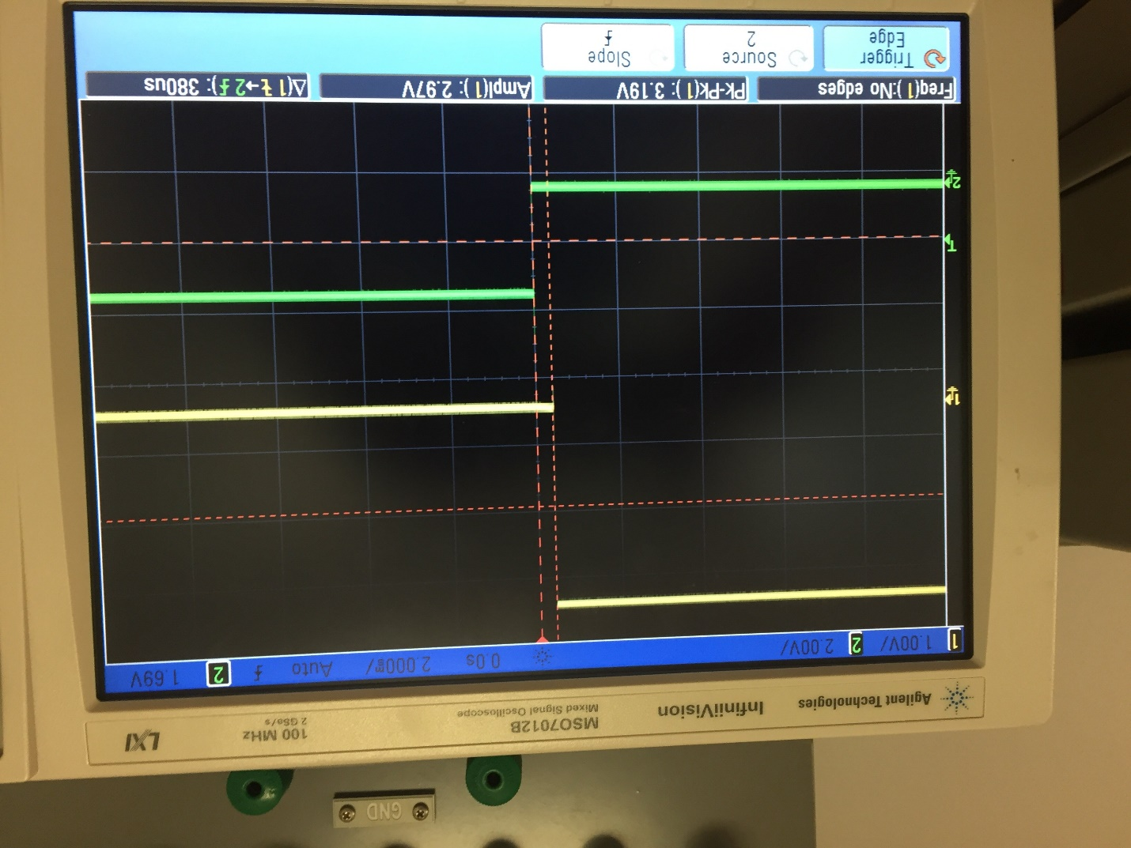

Mmap implementation (C program in tight loop):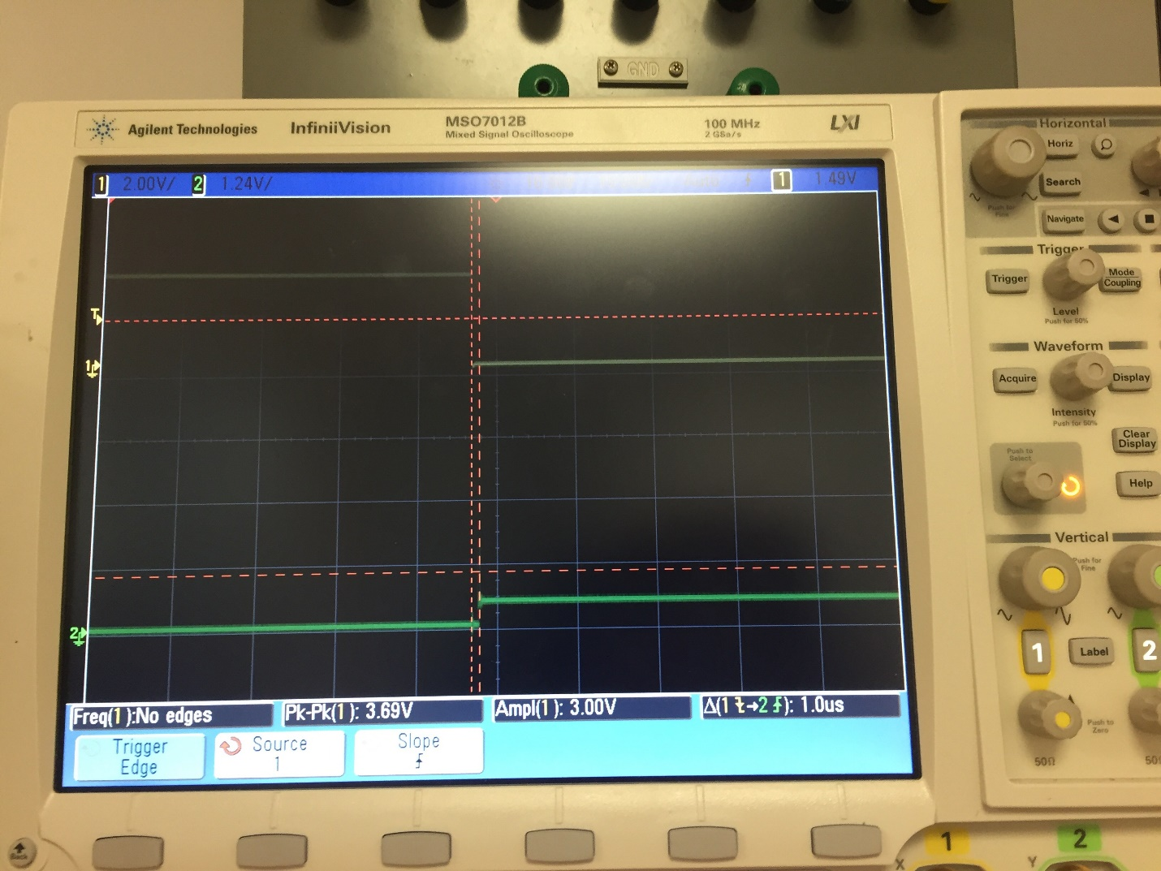

|  |  |
| --- | --- |
| **Implementation Type** | **Timing** |
| Mmap in c | <1 us |
| Kernel Driver | About 380 us |
| Python | About 10 ms |